Cybersecurity Foundations
Network—Operating System—Database—Cloud

Infrastructure Security Plan
for
infrastructure n°2

prepared by
LOUIS DESGRÉE
on
MONDAY 9TH JUNE



Infrastructure Security Plan Introduction

Steps in development of the Infrastructure Security Plan are shown in Figure 1. This same plan can be following for any type and size of organization, be it a small home network or a large multi-national enterprise.
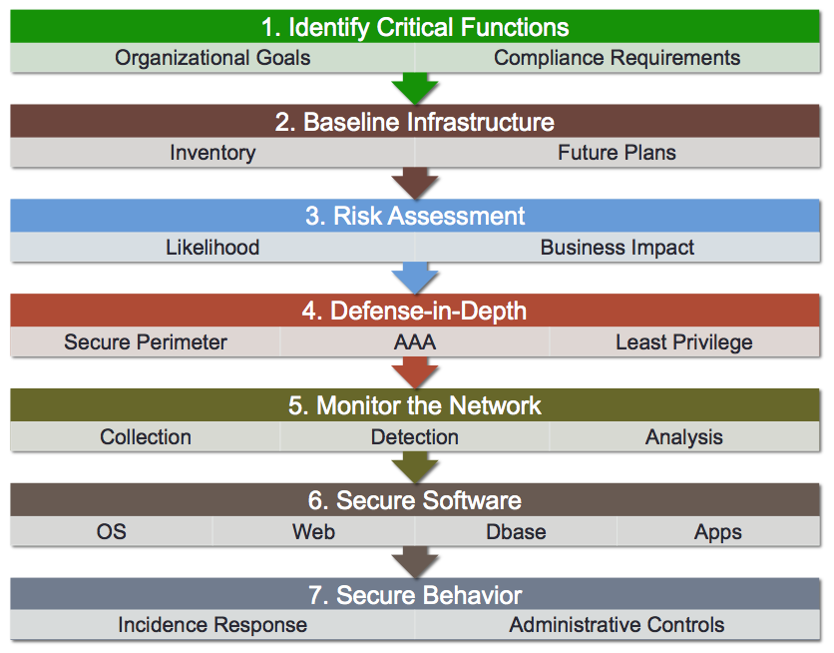

Figure 1. Steps in Developing a Infrastructure Security Plan

Remember that the overall goal of an Infrastructure Security Plan to define architecture for the enterprise that is resilient to a wide range of possible cyber attacks and exploits against the system. The be “cyber resilient” means that identified Critical Functions of the organization continue to operate (or very quickly recover), even in times of cyber attack. No organization has the resources to fully harden every information system from every type of potential cyber attack. The first step in developing a Infrastructure Security Plan is to define Critical Function and supporting IT (information technology) infrastructure, so that limited security resources can be targeted on critical functions. We will identify Critical Functions in Step 1.

1. Identify Critical Functions

Identify at least three critical functions of the organization that are supported by IT infrastructure.
Examples of critical organizational functions
- Point-of-Sale transactions for a retail company
- Current and accurate shipment tracking information for a shipment company
- Privacy of donor records for a non-profit organization
- Privacy and security of records for a government intelligence service
- Email services (availability and confidentially) for a multi-office legal firm
- Availability and Security of a Website for an online retailer
- Availability and Confidentiality of an Internet link for a “work at home” vacation sales associate
- Secure mobile access to real estate information for an “on the go” real estate appraiser
- Available home network Internet (specifically Netflix) access for a dedicated “House of Cards” fan. (“Critical” is as defined by the organizational head)

First, the agency depends on fast and reliable access to its property listings database that resides on the shared workstation in the main office. Every sale begins with up-to-date information about acreage size, zoning restrictions, and asking price, so any delay in reaching that data directly harms revenue. Both the branch staff and the mobile agents query this database throughout the day, which makes its availability the backbone of daily operations.
In tandem with database access, continuous and trustworthy electronic mail is essential. Listing updates arrive from sellers, legal documents move between offices, and contracts must reach clients without interruption. Because the agency relies on an external provider for mail hosting, the confidentiality and integrity of those messages hinge on properly secured connections and a sound backup strategy that prevents data loss in case of provider outages.
Finally, secure mobile connectivity is a mission-critical requirement. Five agents in the field use their iPhones to pull listing photos, price adjustments, and driving directions while standing in front of a property. Each handset tunnels into the main office through a virtual private network, turning the public cellular network into a private lane for sensitive client data. If that encrypted path fails or leaks information, agents cannot close deals on-site and the agency risks exposing confidential records.

Fill in Table 1 with the Critical Functions for this organization.
Columns in Table 1 are:
- Function- Name and short deception of the Critical Function
- Security Triad- List the Security Triad aspects most important to this function (Availability, Integrity, Confidentially)
- Impact if Compromised- What could happen if this Critical Function is compromised (negative impact to the organization)
- Supporting IT Infrastructure- short list of the network, systems, software, etc. that provide IT infrastructure supporting the critical function

Function | Security Triad Aspects (Availability, Confidentiality, Integrity) | Impact if Compromised | Supporting IT Infrastructure
1) Property listings database access for staff in both offices | Availability Integrity | Agents cannot retrieve or update property details. Sales are delayed or lost and data errors spread to clients. | Shared Windows workstation acting as file server at main office. Local network switch. VPN tunnel from branch office.
2) Email communication with clients and legal partners | Availability Confidentiality Integrity | Missed contract deadlines and lost trust if messages are delayed altered or exposed. Possible legal liability for privacy breach. | External email hosting service. ISP link. Workstations running Windows 7 with Outlook.
3) Secure mobile VPN connection for field agents using iPhone 5 devices | Availability Confidentiality Integrity | Agents in the field are cut off from real time data. Deal negotiations stall and client information may leak over public networks. | Five iPhone 5 handsets. VPN gateway on main office firewall. Internet connectivity through cellular network.

Table 1. Critical Functions

2. Baseline Infrastructure

The second step will be to develop a baseline of
- The current security state of the infrastructure, including networks, entry/exit points, systems, software, and existing security controls
- Identify any near term plans to upgrade or modify the Infrastructure, which will impact the Security Plan
In development of a Security Plan for production use, this step would likely include a network inventory. For this assignment, estimates and assumptions are sufficient.

- Provide an Overall Description of the Infrastructure
(If possible, include a diagram or drawing showing major components of the existing architecture)
The agency operates two fixed sites, and a fleet of mobile devices all tied together by Internet links. At the main office two Windows 7 workstations sit behind an ADSL modem and a dedicated firewall appliance. One of those workstations also serves as the central database and file server using Windows for Workgroups. Twenty-five miles away the branch office hosts two more Windows 7 workstations connected through its own ADSL modem but without a local firewall. Finally, five iPhone 5 devices in the field establish VPN tunnels back to the main office whenever agents need to pull listing data or update records on the go. All sites and devices depend on a single ISP for email and web access.
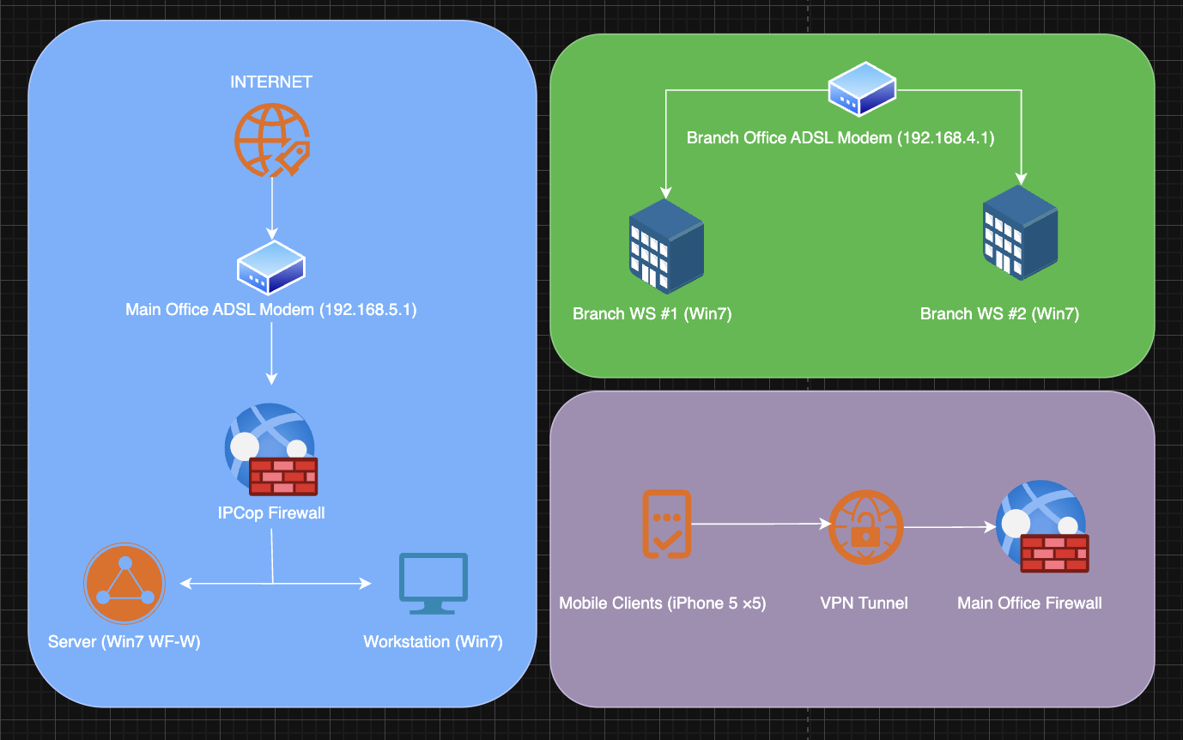

- Describe the Network or Networks
(Include wired and wireless networks)
1. The main-office LAN consists of the firewall’s green interface and the two Windows 7 machines. Ports for HTTP, HTTPS, VPN and SMB share data and host the listings database.
2. The branch-office LAN is flat and unfiltered. Its two workstations and its ADSL modem share a small local switch. Without a firewall this network trusts only the ISP’s perimeter.
3. The mobile network lives on the public cellular network. Each iPhone uses built-in VPN software to tunnel through the public Internet into the main-office firewall’s VPN endpoint. Once inside the tunnel the mobile client becomes a temporary node on the main-office LAN.

- List EVERY Entry and Exit Point to the Infrastructure
Remember that every entry/exit point from a network is a potential attack surface. Include Internet connection, Virtual Private Network (VPN), branch offices, business partners, etc

1. The main office ADSL modem connects the agency LAN to the ISP-managed Internet backbone.

2. The branch office ADSL modem provides a separate Internet gateway directly to its workstations.

3. The VPN gateway on the main office firewall allows remote iPhones to join the corporate LAN over the public network.

4. Email traffic flows in and out of both offices through the ISP’s mail servers using standard SMTP and IMAP ports.

5. The branch office workstations connect back to the main office server for database queries and file shares, traversing the public Internet without local firewall protection.

- List Systems (Server, Workstation, Laptop, Tablet, Mobile Device) in the Infrastructure, and the Operating Systems and Applications (that support critical functions) that Reside on Them
Can be provided in Table or list form. Describe all systems, operating systems, and applications that support critical functions
Operating System | Operating System | Applications Supporting Critical Functions
Main Office Server | Windows for Workgroups | Listings database service, file share, VPN endpoint
Main Office Workstation 1 | Windows 7 | Web browser, email client, database query tools
Main Office Workstation 2 | Windows 7 | Listing update tools, document editor, email client
Branch Office Workstation 1 | Windows 7 | Web browser, email client, remote database access via VPN
Branch Office Workstation 2 | Windows 7 | Web browser, email client, remote database access via VPN
Mobile Device (five units) | iOS 10 | Mobile CRM app, secure VPN client, web browser for listing lookup and email access

- Describe OS Patch Management in Place
In Table of List form, define the patch management for all operating systems (e.g., never updated, monthly, automatic updates, etc.)

Operating System | Patch Frequency | Update Method
Windows 7 on all workstations | None (end of support) | No further security patches available
Windows for Workgroups on server | Manual monthly | Administrator downloads and installs updates from vendor archive
iOS 10 on mobile devices | Automatic | Over-the-air updates enabled by default
IPCop Firewall OS | Quarterly | Automated via built-in package manager

- Describe Workstation and Server Security Controls in Place
In Table of List form, define security controls for all operating systems (e.g., none, virus protection with automatic updates, host based firewalls)

System Type | Antivirus/Endpoint Protection | Host Firewall | Access Control
Main Office Server | None | IPCop default | Local user accounts with passwords
Main Office Workstations | None | Windows firewall off by default | Local user accounts with passwords
Branch Office Workstations | None | None | Local user accounts with passwords
Mobile Devices | iOS built-in malware protections | VPN enforces tunnel endpoint filter | Device passcode required
IPCop Firewall Appliance | N/A | Stateful packet inspection enabled | Firewall rules restrict ports HTTP HTTPS VPN

- Describe AAA (Authentication, Authorization, Accounting)
Describe how users are currently Authenticated and Authorized. Is there Accounting of user activities?

Currently each user on a Windows workstation or on the shared database server logs in with a local account and password managed on that machine. Mobile agents authenticate into the corporate network by supplying the same device-level passcode and a VPN pre-shared key configured on the main-office firewall. There is no central directory service or single sign-on, so each host maintains its own user database. Once authenticated, file and database permissions on the server enforce which users may read or write listing records. Authorization is therefore handled by local OS access control lists rather than by roles or groups defined in an enterprise directory.

Accounting of user activity is minimal. Workstations and the server do not forward login or file-access logs to a central log server. The main-office firewall does record VPN connection events and source IP addresses, but these logs are stored locally on the appliance with no automated archive or correlation. As a result there is no comprehensive audit trail showing which user viewed or modified which record at what time.

- Describe Any Other Security Controls
Describe any additional security controls in place such as firewalls, IDS/IPS. In general terms, describe the policies configured on additional security control systems.

At the perimeter of the main office network sits a dedicated firewall appliance configured for stateful packet inspection. It blocks all inbound traffic except web browsing (ports 80 and 443), email (SMTP, IMAP), and the VPN tunnel port. Outbound traffic is largely unrestricted, though the firewall enforces network address translation to hide internal IPs. The branch office has no local firewall, relying entirely on the ISP’s basic router safeguards.

There is no intrusion detection or prevention system deployed anywhere in the infrastructure. Email flows through the ISP’s hosted service, which applies spam filtering and basic malware scanning. Mobile devices benefit from Apple’s built-in malware protections and sandboxing but lack a managed endpoint protection client. Beyond password policies on each machine, there are no network segmentation, network access control, or host-based firewall rules on Windows workstations. Physical security at both offices is provided by locked doors and visitor sign-in, but no electronic door access logs are maintained.

Risk Assessment

Based on the defined Critical Functions, and the survey of the infrastructure (and security controls) that support those critical functions, this step performs a risk assessment of the likelihood and impact of possible cyber security attacks to the system.
A Security Plan for a production system would likely identify scores (or even hundreds) of possible attack vectors to the system. For this exercise, you are being asked to identify the 3 most important possible attack vectors. Enter your three top cyber risks in Table 2, and describe the means of exploit, likelihood, and impact. For likelihood and impact, include a short description as the reason for the rating given. An example risk is shown in the first column of the table.
Note that a “top” cyber risk would have high likelihood or high impact (or both). There is no point in expending resources to add controls to protect against something that is likely to never happen, and even if it did happen, the impact on Critical Functions would be negligible. There is always the option to “accept the risk,” rather that to expend resources to implement a control.
Next we will proceed to adding security controls to the system (Defense-in-Depth, Monitor the Network, etc.). The purpose of security controls is to either decrease the likelihood of a cyber risk or to decrease the impact to critical systems if it did happen.

Top Cyber Risks to Critical Functions | Means of Exploit | Likelihood (reason) | Impact on Critical Functions (reason)
Example: Company Website Denial-of-Service | Distributed Denial-of-Service attack using Bot-nets | High- current infrastructure has no protections, known motivations for hacktavist attacks | High- Lack of corporate website availability would send wrong message to potential customers
Ransomware encryption of main server files | Malicious email attachment or direct exploit of unpatched SMB service to install ransomware | Medium No antivirus, Windows 7 end-of-life increases risk | Severe Database and file shares inaccessible, halting all listing queries and updates
Credential theft via spear phishing | Targeted email with fake VPN or server login page that harvests user credentials | High No anti-phishing controls, users reuse passwords | High Unauthorized access to listings database and email, data exfiltration and manipulation
Branch office workstation compromise | Attacker scans public IP, exploits unpatched remote desktop or SMB vulnerability to deploy malware | High No local firewall, Windows 7 unpatched | Medium Branch operations disrupted and malware could pivot over VPN to impact main office systems

Table 2. Top Risks to Critical Function

Defense in Depth

Based the cyber risks identified in Step 3 above, identify the Defense-in-Depth controls you recommend to be implemented to increase the cyber resilience of Critical Functions.
Remember that Defense-in-Depth controls include securing the perimeter (firewalls), conjuring AAA systems, and importantly least privilege.

For Defense-in-Depth, answer each of the questions below.

- How will defend the perimeter to the infrastructure?
List controls, and where they would be located

To defend the perimeter we will replace the aging modem firewalls at both offices with modern security gateways that inspect application traffic and block known threats. At the main site the new gateway will sit between the ADSL modem and the internal network, enforcing policies for web browsing email and VPN tunnels. An identical gateway at the branch site will ensure both locations share the same protections. In addition we will deploy an intrusion detection and prevention appliance on the external link to spot and stop unauthorized scans or exploit attempts before they reach any workstation or server. Internally we will create separate network segments for user devices and the listings server so that even if one segment is breached the other remains protected.

- How will AAA be implemented?
List implementation of Authentication, Authorization, and Accounting
For authentication authorization and accounting we will introduce a centralized directory service. All users and service accounts will log in with unique credentials and a second factor such as a time-based code. Access rights to files shares and applications will be granted through role based controls in the directory so that each person sees only the data and functions required by their job. Every login operation as well as file access and configuration change will be recorded and forwarded to a security information and event management system. That system will maintain a time-stamped audit trail for all critical actions including VPN logins and firewall configuration edits.

- How will you ensure “least privilege”?
List controls, and where they would be located.
To ensure least privilege we will require that all staff operate with standard user accounts that cannot install software or modify system settings. Administrator rights will be restricted to a small set of dedicated service accounts that have no interactive login and whose credentials are stored in a hardened vault. On the listings server we will apply strict access control lists granting read-only access to general staff and full rights only to the database and backup services. Mobile devices and branch workstations will run under locked-down profiles that prevent installation of unapproved applications. By separating human accounts from service accounts and granting each the minimum permissions needed we reduce the risk that a compromised user or compromised process can escalate privileges.
- How will you implement “patch management” to ensure that systems are kept up to date in the most secure state
Manual or automated patch management is possible.
Patch management will follow a hybrid model combining automated updates with scheduled validation windows. Windows workstations and servers will join a central WSUS server, which automatically downloads and stages Microsoft security patches. Each month, a brief maintenance window will apply those updates during off-hours, followed by automated health checks to confirm service availability. The Linux-based firewall appliance and the intrusion prevention system will retrieve their own security patches from a vendor-maintained repository and install them quarterly during scheduled maintenance. Mobile devices will continue to receive Apple’s over-the-air updates automatically, with the MDM solution enforcing installation within 24 hours of release to guarantee all iPhones remain protected against the latest vulnerabilities.

- Describe any other Defense-in-Depth methods to be Implemented
Could include host based firewall, virus protection, etc.
Beyond these layers, we will deploy host-based firewalls on every workstation and server to enforce local policies in addition to the network perimeter rules. A managed endpoint protection platform will provide antivirus and anti-malware scanning with real-time signature updates and behavioral analysis. All sensitive data at rest on the listings server will be encrypted using disk-level AES encryption, and backups will be stored off-site in an encrypted form. Regular vulnerability scans and annual penetration tests will probe for misconfigurations or exploitable flaws, and the results will feed back into the patch and configuration management process. Finally, we will institute ongoing security awareness training so that users can recognize phishing attempts and other social engineering tactics, reinforcing the human layer of our defense-in-depth strategy.

Monitor the Network

As we covered in the lectures, Defense-in-Depth is “necessary but not sufficient” to protect against advanced threats.
In this section, you will define how you will monitor the network for this infrastructure.

- Describe the tools that will be implemented to monitor the network
Tools could include automated systems and well as manual procedures, such as reviewing firewall logs on a weekly basis. Automated tools can include configuration of system logging, firewall logging, packet capture and analysis, and IDS/IPS systems.
To gain full visibility into every corner of our network we will deploy an integrated suite of monitoring tools. First, all firewall events will be forwarded in real time into a security information and event management platform where logs from our next-generation gateways at both offices and the VPN concentrator will be parsed, correlated, and normalized. At the same time we will run an intrusion detection and prevention system on the perimeter links; this appliance will inspect packets for known signatures and anomalous behavior, generate alerts for suspicious traffic, and even block traffic that matches high confidence exploit patterns. In addition, we will collect NetFlow data from each gateway to identify unusual communication flows or sudden spikes in bandwidth. To catch stealthy threats inside the LAN we will configure each Windows workstation and the server to send system and application logs such as login events and file-access records to the SIEM. Finally we will schedule regular packet captures on critical VLANs so that if an incident requires deep forensics we already have a rolling window of raw traffic to reconstruct an attacker’s steps.

- For aspects of network monitoring that require human analysis, describe the frequency of the analysis activity
Daily? Weekly? Monthly?
While the automated sensors will raise immediate high-priority alarms, certain aspects of monitoring depend on human review. Every morning the security team lead will scan the SIEM dashboard for any new alerts that lack an automated response rule, triaging false positives and escalating real threats. Once per week a scheduled report will enumerate the top firewall deny events and the most frequent IDS signatures so that unusual patterns such as repeated scanning or data exfiltration attempts are spotted even if they did not cross a high-severity threshold. Monthly the team will review NetFlow summaries to verify that peaks and shifts in traffic volume match legitimate business activities rather than covert data transfers. Finally, on a quarterly basis the security operations manager will audit the integrity of all log sources, ensuring that no device has fallen out of the logging pipeline and that storage quotas and retention policies remain correctly enforced. This combination of real-time automated detection and regular human inspection guarantees that the network remains under continuous watch without overwhelming analysts with noise.

Secure Software

Following the principles describe in Modules 5 to 8 of the course (Secure Windows, Secure Linux, Secure Web, Secure Database), describe any software specific controls to be implemented in operating systems, website, and databases in the infrastructure.

- Operating System Specific Controls
Describe any controls for the specific operating systems implanted in the infrastructure.
On every Windows machine we will enable and configure the built-in host firewall to only allow the minimal ports needed for each role. We will turn on User Account Control to force all software installations and configuration changes to require explicit administrator approval. We will remove or disable legacy features such as SMB version one and guest accounts. Local Security Policy settings will enforce strong password complexity and account lockout thresholds. The server disk will be encrypted with BitLocker so that data at rest remains protected if the hardware is stolen. Event auditing will be turned on for logins and object access so that all changes to critical files and system settings generate audit entries. Mobile devices under iOS will be enrolled in a mobile device management system that enforces a strong passcode, device encryption, and automatic lock after inactivity.
- Website Specific Controls
Only applies if public or private websites are included in the enterprise. If not applicable just write NONE.

NONE

- Database Specific Controls
Describe and specific controls for databases included in the infrastructure.
The property listings database will require encrypted connections using TLS so that all queries and updates travel over an encrypted channel. Database user accounts will be defined according to roles, granting read-only access to agents and read/write access only to the backup and administrator service accounts. The database files will be stored on an encrypted volume separate from the operating system and backed up nightly to an off-site encrypted repository. We will enable change-tracking and audit logging for every table so that every insert, update, or delete operation records which user initiated it and when. Regular vulnerability scans will check for missing database patches and misconfigurations, and all database engines will be updated monthly to ensure we remain protected against known exploits.

Secure Behavior

This section completes the security plan with coverage of the human factor.

- Administrative Controls
Briefly describe the Administrative controls that would be needed to address the identified risks to Critical Functions. This could include handling of password assignments, process for employee account termination, secure physical control of computers access, etc. Note that this section is only asking for a summary description. Actual administrative controls are usually described in extensive processes and procedures.
In order to govern secure behavior across the agency, we will establish policies and procedures for user lifecycle management and physical security. Passwords must be assigned according to a strong complexity standard and rotated on a regular schedule with a minimum length of twelve characters and multi-factor authentication enabled for all privileged accounts. When an employee leaves or changes roles, IT will disable their directory account and VPN access immediately and remove any local access rights on all workstations. Physical access to both offices will require badge-based entry and a visitor sign-in process. All computers will be locked in secure cabinets when not in use, and end-of-life hardware will be wiped using approved tools before disposal or recycling. In addition we will require annual security training to ensure every staff member understands phishing risks, data handling procedures, and how to report suspected incidents.

- Incident Response
Briefly describe to process that would be used to respond to a securing incident impacting Critical Functions. Include answers to the following aspects of incident response
- Who would be responsible?
- What actions would they initially take?
- How would the scope and impact of the attack be determined?
How would Critical Functions be quickly restored?
Our incident response program will be owned by the IT security manager working in concert with the agency’s executive sponsor. In the event of a suspected breach, the security manager will convene the response team which includes the network administrator, the database administrator, and an appointed communications liaison. Their first actions will be to contain the incident by isolating affected systems, preserve critical logs and forensic evidence, and notify senior leadership. To determine the full scope and impact, they will review firewall and VPN logs in the SIEM platform, examine intrusion detection alerts, and scan all endpoints for indicators of compromise. At the same time they will consult recent backups to verify data integrity. Once the team understands which functions are impaired they will restore critical services by failing over to a clean backup of the listings database and re-provisioning affected user workstations using known good images. Throughout the process the response team will maintain a running timeline of actions taken and prepare a lessons-learned report to refine the security plan and prevent future incidents.

